Decompose a number

DESCRIPTION:
Decompose a number num into an array (tuple in Haskell, array of arrays long[][] in C# or Java) of the form [[k1,k2,k3...], r], ([k1,k2,k3...], r) in Haskell, [[k1,k2,k3...], [r]] in C# or Java) such that:
- each kn is more than one
- eack kn is maximized (first maximizing for 2 then 3 then 4 and so on)
- and 2k1 + 3k2 + 4k3 + ... + nkn-1 + r = num

SOLUTION:
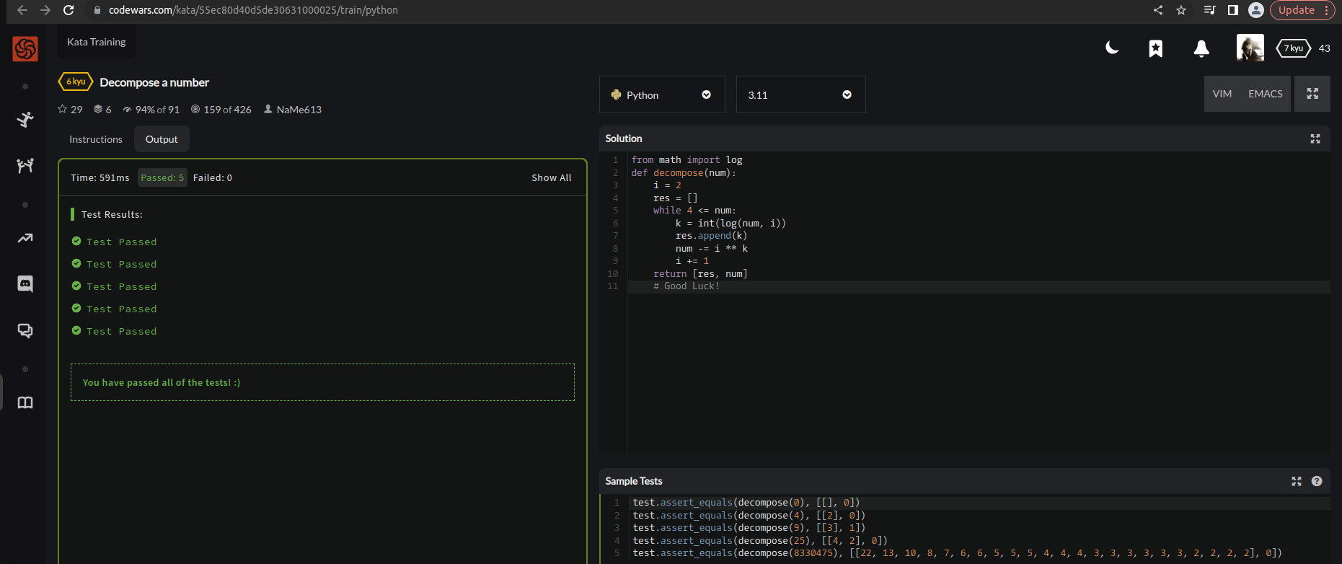

EXPLANATION:
We’re asked to calculate the total decompose a number into array. So therefore, to decomposing an array in our python function we’ll take a positive integer num as an input, and returns a list containing two elements. Scanario of algo is based on firstly by:
- Initializing i to 2, and an empty list res to store the exponents of the powers.
- While num is greater than or equal to 4. Compute the largest exponent k such that i**k is less than or equal to num, using the logarithm function. Append k to the list res.
- Subtract i**k from num to update its value.
- Increment i by 1 to move to the next consecutive integer.
- Return the list res and the remaining value of num.

